TRUSTSHARE
Secure File-Sharing System

1. Project Overview
Trust Share is a secure file-sharing platform designed to help users upload, store, and share digital files with controlled access. It focuses on protecting sensitive documents through AES-256 encryption, user authentication, permission-based sharing, temporary access links, download tracking, and audit logging.

2. Refined Project Objectives
- Secure file upload and storage: To develop a platform that enables authenticated users to upload and securely store digital files.
- AES-256 encryption: To protect stored files by applying AES-256 encryption, helping keep file contents confidential if storage is accessed without authorization.
- Authentication and access control: To verify user identities and restrict platform access to authenticated users.
- Permission-based sharing: To allow file owners to share documents with selected users and define the access permissions granted to them.
- Temporary access links: To generate time-limited sharing links so that access is available only for a specified period.
- Download tracking and audit logs: To record file download activity and maintain audit logs that help review important file-access events.
- Prevention of unauthorized access: To reduce unauthorized access to sensitive documents through authentication, permission checks, and controlled sharing.
- Secure collaboration: To support safer file exchange and collaboration between individuals and organizations.

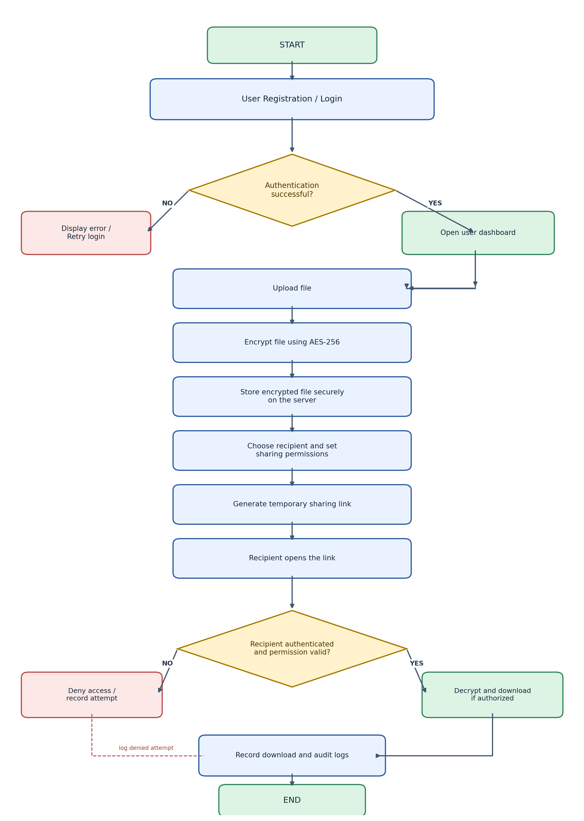
DAY-2

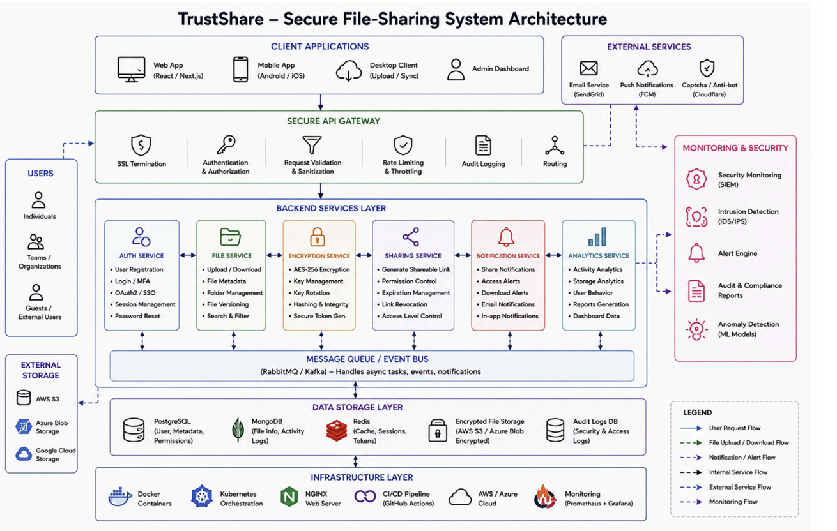
Figure 1: Proposed TrustShare secure file-sharing system architecture

System Architecture – Layer-by-Layer Explanation
The architecture is divided into layers. Each layer has a specific responsibility, which makes the system easier to maintain and secure.

Client Applications
The user interface through which people use TrustShare. It may be a web app, mobile app, desktop client or admin dashboard. Users select files, upload them, create share links and manage permissions.

Secure API Gateway
The gateway is the entry point for requests. It checks HTTPS/SSL, authentication, authorization, input validation, rate limits and request logs. It then forwards valid requests to the correct backend service.

Backend Services Layer
This layer contains separate services for account management, file handling, encryption, sharing, notifications and analytics. Each service performs one main task.

Message Queue / Event Bus
A queue such as RabbitMQ or Kafka handles background work. For example, after a file is uploaded, the system can encrypt it, update metadata and send a notification without keeping the user waiting.

Data Storage Layer
PostgreSQL stores structured information such as users, permissions and share links. MongoDB can store activity events or flexible metadata. Redis can store short-lived sessions, cache data and temporary tokens. Encrypted file contents are stored in object storage such as AWS S3 or Azure Blob.

Infrastructure Layer
Docker packages services into containers. Kubernetes can manage containers. NGINX acts as a web server/reverse proxy. CI/CD automates testing and deployment. Monitoring tools help administrators observe system health.

External Services
Email, push-notification and CAPTCHA services support account verification, alerts and bot prevention.

Monitoring and Security
Security monitoring, intrusion detection, alerting, anomaly detection and audit reports help identify suspicious activities.

Main Backend Services
Service | Responsibilities
Authentication Service | Registration, login, password reset, MFA/OTP, OAuth/SSO and session management.
File Service | File upload/download, metadata, folders, search, filtering and version history.
Encryption Service | AES-256 file encryption/decryption, key management, key rotation, integrity checks and secure token generation.
Sharing Service | Shareable links, access permissions, expiry dates, link revocation and access-level checks.
Notification Service | Email, in-app and push notifications for shares, downloads and security alerts.
Analytics Service | Activity summaries, usage reports, download statistics and dashboard data.

Secure File Upload and Sharing Workflow
- User signs in. The API Gateway verifies the login token and checks whether the user is allowed to perform the action.
- User selects a file and sends it over HTTPS to the File Service.
- The File Service validates the file type, file size and request. It creates a unique file ID.
- The Encryption Service encrypts the file using AES-256. The encryption key is protected by a key-management mechanism and is not stored as plain text in the database.
- The encrypted file is saved in object storage. PostgreSQL stores the file name, owner, storage key, size and encryption metadata.
- When the owner shares a file, the Sharing Service creates a random, hard-to-guess token and stores only its hash, along with permissions and expiry time.
- The recipient opens the link. The system validates the token, expiry, revocation status and requested permission before allowing access.
- After a successful download or denied attempt, the system records an audit event. The Notification Service may inform the owner.

Database Design Overview
A relational database such as PostgreSQL is recommended for the core records because users, files, permissions and share links have clear relationships. The following schema is a proposed logical design. Column types can be adjusted to match the selected database.

Core Database Tables

users
Stores registered user accounts.

sessions
Stores active login sessions or refresh-token records.

folders
Stores folders created by users.

files
Stores file details, not the actual file bytes.

file_versions
Stores information about previous versions of a file.

shares
Stores a share link and its access rules.

share_recipients
Optional table to restrict a share to named users.

download_logs
Tracks file access and download attempts.

audit_logs
Records important security and account activities.

notifications
Stores notifications shown to users.

encryption_keys
Stores key references and key lifecycle metadata only.

Conclusion
Trust Share combines authentication, encryption, permission-based sharing, secure storage and audit logging. Separating the system into layers and services makes it easier to develop and maintain. The proposed database schema stores the information required to manage users, files, versions, links and security activities. The design can first be implemented as a simple application and expanded with queues, monitoring and cloud deployment as the project grows.

DAY 3

1. Introduction
Trust Share is a secure file-sharing platform that allows users to upload, store and share files with controlled access. This document presents low-fidelity UI wireframes and a workflow plan. A wireframe is a basic screen layout. A workflow explains the steps a user follows to complete an action.
2. Main Users
User | Main activities
Registered user / file owner | Sign in, upload files, organize files, create sharing links, set permissions and revoke links.
Recipient | Open a shared link and view or download a file when access is allowed.
Administrator | Review users and monitor activity and security records.

3. UI Wireframes
These are proposed basic screen layouts for the first version of Trust Share. They show the main fields, buttons and information. Final colors and styling can be added during frontend development.
3.1 Login Screen
Purpose: Allow an existing user to sign in.
┌────────────────────────────────────────────────────────┐
TRUSTSHARE
Secure File-Sharing System
Email address
[________________________________]
Password
[________________________________]
[ Sign In ]
Forgot password? Create account
└────────────────────────────────────────────────────────┘

3.2 Registration Screen
Purpose: Allow a new user to create an account.
┌────────────────────────────────────────────────────────┐
CREATE ACCOUNT
Full name [______________]
Email address [______________]
Password [______________]
Confirm password [______________]
[ Create Account ]
Already registered? Login
└────────────────────────────────────────────────────────┘

3.3 User Dashboard
Purpose: Show the user's files and main actions after login.
┌────────────────────────────────────────────────────────┐
TRUSTSHARE Profile | Logout
------------------------------------------------------------
Dashboard | My Files | Shared Files | Activity
------------------------------------------------------------
Welcome to Trust Share!
[ + Upload File ] [ + Create Folder ]
Recent Files
File Name Updated Actions
Project.pdf Today View | Share
Notes.docx Yesterday View | Share
Recent Activity | Shared with Me
└────────────────────────────────────────────────────────┘

3.4 Upload File Screen
Purpose: Select a file and upload it securely.
┌────────────────────────────────────────────────────────┐
UPLOAD A FILE
[ Choose File ]
Selected file: __________________
Folder: [ Select folder v ]
[ Upload Securely ] [ Cancel ]
Upload status: Waiting / Uploading / Complete
File is validated and encrypted before storage.
└────────────────────────────────────────────────────────┘

3.5 Share File Screen
Purpose: Choose who can access a file and for how long.
┌────────────────────────────────────────────────────────┐
SHARE FILE
File: Project.pdf
Recipient email (optional)
[________________________________]
Permission: ( ) View ( ) Download
Link expiry: [ 1 day v ]
Download limit: [ Optional ____ ]
[ Generate Secure Link ]
Share link: [ Copy Link ]
[ Revoke Link ]
└────────────────────────────────────────────────────────┘

3.6 Recipient Shared-Link Screen
Purpose: Check a shared link before allowing file access.
┌────────────────────────────────────────────────────────┐
SHARED FILE
File: Project.pdf
Shared by: File owner
Link status: Valid / Expired / Revoked
Permission: View / Download
[ View File ] [ Download ]
If expired or revoked:
This link is no longer available.
└────────────────────────────────────────────────────────┘

3.7 Activity / Audit Screen
Purpose: Show file and security activities to authorized users.
┌────────────────────────────────────────────────────────┐
ACTIVITY HISTORY
Date & Time Activity Result
11 Nov, 10:00 File uploaded Success
11 Nov, 10:15 Link created Success
11 Nov, 10:30 File download Success
Filters: Date | File | Activity type
Do not display passwords or raw share tokens.
└────────────────────────────────────────────────────────┘

4. Workflow Planning
4.1 Login Workflow
- User opens the Trust Share application.
- User enters an email address and password.
- The system verifies the login details.
- If the details are correct, the dashboard opens.
- If the details are incorrect, an error message appears and the user can try again.
4.2 File Upload Workflow
- User signs in and opens the dashboard.
- User selects Upload File and chooses a file.
- The system validates the file type and size.
- The Encryption Service encrypts the file using AES-256.
- The encrypted file is saved in secure object storage.
- File information and storage reference are saved in the database.
- The system displays an upload-success message.
4.3 File Sharing Workflow
- The owner selects a file and clicks Share.
- The owner chooses the permission and link expiry time.
- The system generates a secure random sharing token and stores its hash.
- The owner copies and sends the sharing link to the recipient.
- The recipient opens the link.
- The system checks token validity, expiry, revocation status and permission.
- If all checks pass, the recipient can perform the permitted action; otherwise, access is denied.
- The system records the access or download attempt in the logs.
4.4 Revoke Link Workflow
- The owner opens the sharing details.
- The owner selects Revoke Link.
- The system marks the link as revoked.
- Future attempts to use that link are denied.
5. Overall Workflow Flowchart
START
|
Open TrustShare
|
Enter login details
|
Are login details valid?
|-- NO --> Show error --> Try again
|
YES
|
Open Dashboard
|
Choose: Upload / Share / View Activity
|
UPLOAD: Select file -> Validate -> AES-256 encrypt -> Store encrypted file
|
SHARE: Set permission and expiry -> Generate link -> Recipient opens link
|
Check link, permission and expiry
|
Is access allowed?
|-- NO --> Deny access and record event
|
YES --> Allow permitted view/download and record event
|
END

6. Suggested Development Plan
Phase | Work | Expected result
1. Planning | Confirm users, features and screen requirements. | Feature list and wireframes.
2. UI Design | Create login, dashboard, upload, share and activity screens. | Basic frontend screens.
3. Database Setup | Create users, files, shares, sessions and audit-log tables. | Database ready for application data.
4. Authentication | Build registration, login and protected pages. | Only signed-in users can access protected features.
5. File Handling | Build file selection, validation, upload and download. | Users can upload and retrieve files.
6. Encryption | Add AES-256 encryption and protected key management. | Files are encrypted before storage.
7. Sharing | Add permissions, expiry and link revocation. | Controlled file sharing.
8. Testing | Test invalid login, invalid files, expired links and unauthorized access. | Issues are identified and corrected.
9. Final Review | Review screens, workflows, security and documentation. | Project ready for demonstration.

7. Basic Test Scenarios
Test scenario | Expected result
Login with correct details | Dashboard should open.
Login with incorrect details | An error message should appear.
Upload a valid file | File should be encrypted and stored.
Upload an unsupported or oversized file | System should reject it with a clear message.
Open a valid sharing link | Only the permitted action should be available.
Open an expired or revoked link | Access should be denied.
Download a shared file | Download activity should be recorded.

